Multi-Factor Authentication (MFA) Guide
To access the University’s services or systems, you may need to verify your identity via Multi-Factor Authentication (MFA).
When you first try to log into one of the MFA-enabled systems or services you will be prompted to configure a secondary authentication method, you only need to do this set up once, unless you change your phone.

Your MFA settings – Set it up now
- Need to set up MFA and have computer and/or a smart phone available?
Update your MFA settings and options – Update it now
- Already set up MFA phone call, but want to use the app instead?
- Got a new phone - add an additional phone to your MFA.
- Want to have multiple ways to MFA, including landline phone call, additional devices and apps?
Having trouble signing in? – Sign in another way

MFA Microsoft Authenticator app set up
The Microsoft Authenticator mobile app is the simplest and most reliable to use.
The app should work on most Android and iOS handsets. Some older devices may not be able to use the app, if this is the case you set up: Authentication phone when registering.
Please note: You will need signal and data on to set up the app, but once configured, the app can be used even if the handset has no mobile signal or internet connection.
Setting up and using the Microsoft Authenticator App
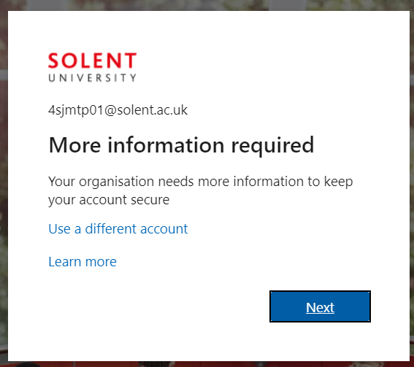
- When you sign in on your computer you will be prompted to provide more information or alternatively click this link to start the process
- Click Next
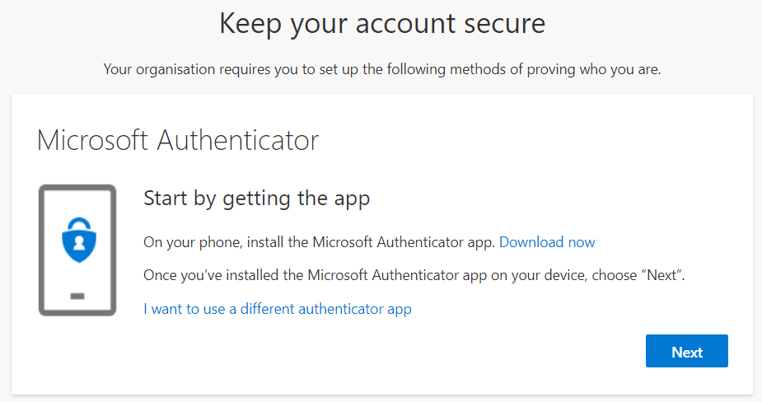
- On your phone, install the Microsoft Authenticator app.
Available from Google Play, the Apple App Store, or the Microsoft App Store
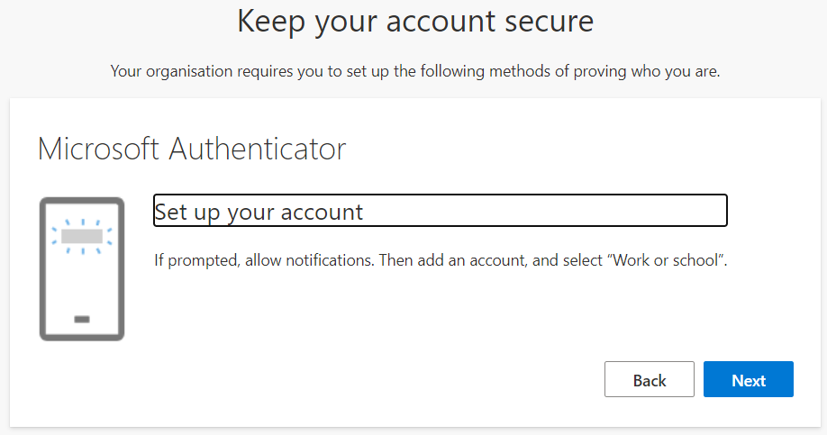
- Once installed click Next on your computer/device
- Once installed, launch the app on your phone and skip through the wizard if required
- Tap on Add account (the + sign) on your phone
- Select Work or school account and accept the app permissions
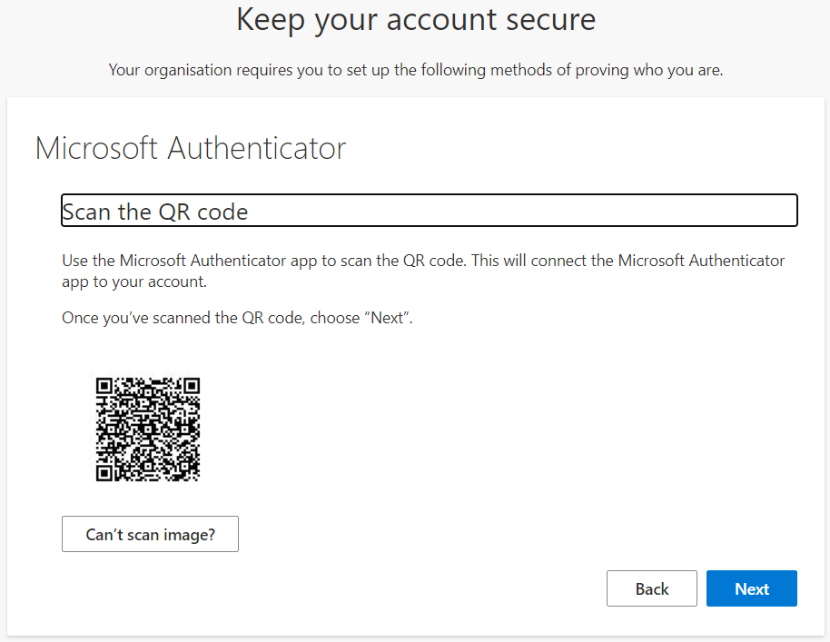
- Click Next on your computer
- Select Scan a QR code on the phone app
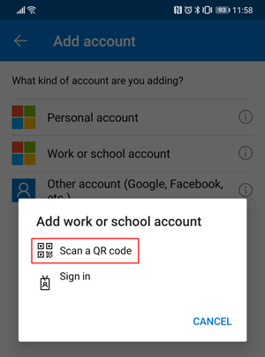
- Use your phone to scan the QR code displayed on your computer
or
If you are doing the whole process on your phone, switch to the keeping your account secure page, click Can’t scan image? and note down the 9-digit code and the URL and enter it manually into the authenticator phone app
Please note:
- iPhone users may have to enable the camera, in Settings in order to scan.
- If you can't use your phone camera, you'll have to manually enter the 9-digit code and the URL.
- Your account will be added automatically to the app and will display a six-digit code.

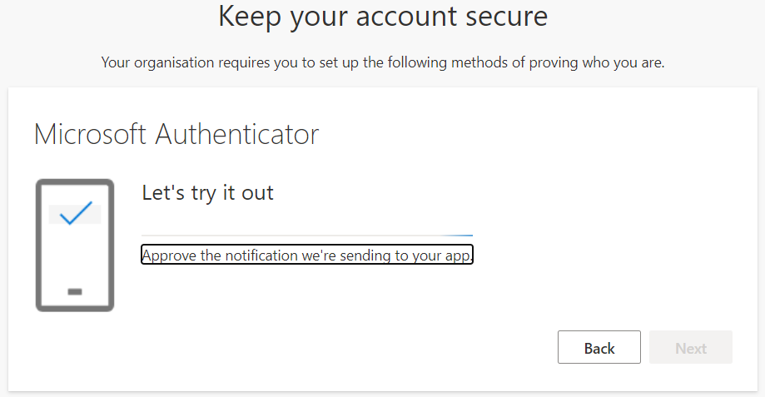
- Click Next on your computer.
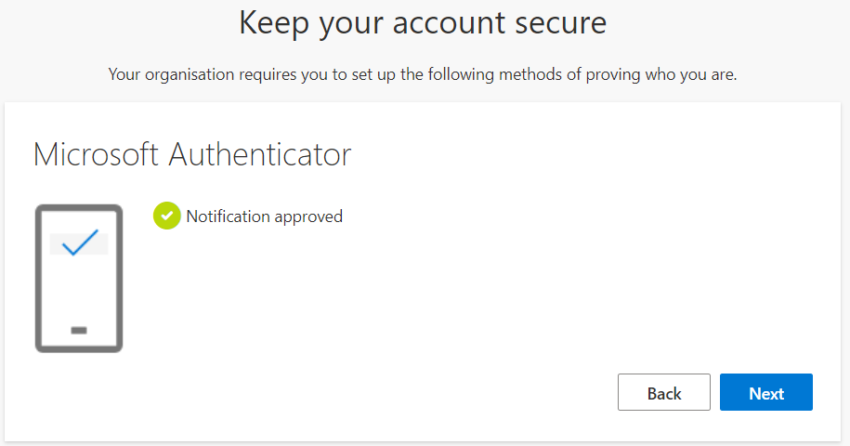
- On your phone, go to the Microsoft Authenticator app and tap Approve on the sign-in prompt.

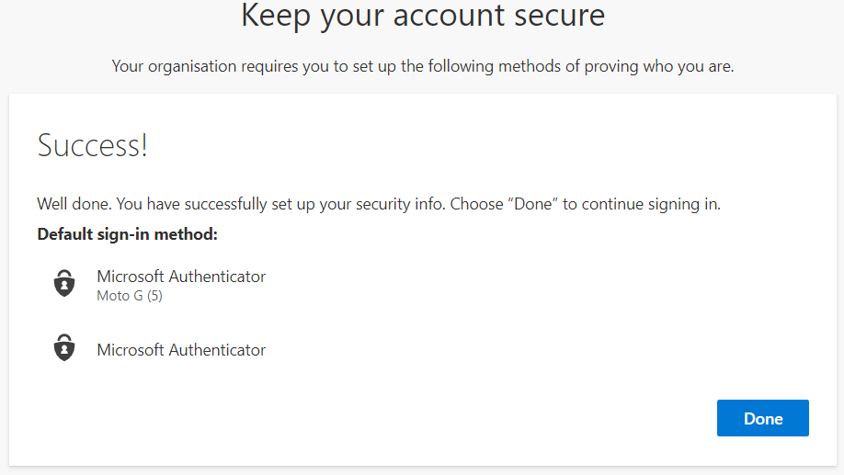
- Click Next on your computer.
- Click Done on your computer.
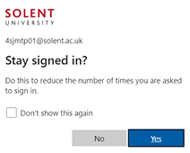
- Check/tick the Don’t show this again option and click Yes
Adding your alternative security contacts
This is an important step!
You need to add a couple of telephone numbers and an email address, which we can use to authenticate who you are, in case the app stops working, or you forget your account password.
- Either click on Security info or go to https://aka.ms/mysecurityinfo
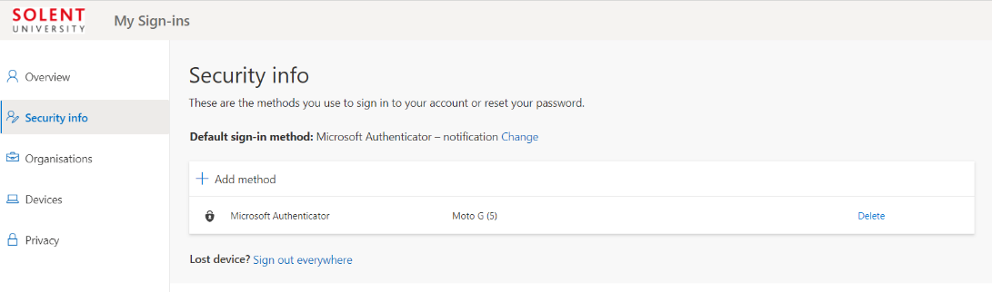
- Click + Add method
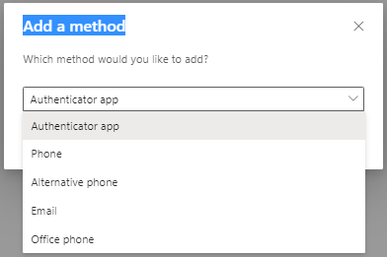
- Select Phone
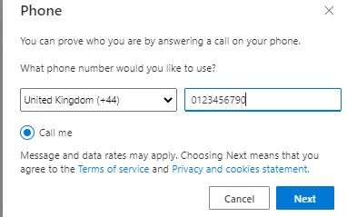
- Add your mobile number and click Next
- Your phone will ring to verify it, once your answer it press the # (hash/pound) to confirm.
- Click Add method to add an additional alternative phone, this can be a landline or alternative mobile and verify it again.
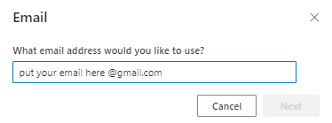
- Click Add method and select email, if you haven’t already registered one for password resets.
- Add an alternative email address (not your university one) and click Next
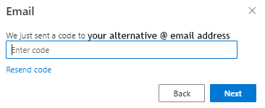
- Go to that email address and find and copy the verification code, paste it into the box to confirm
- Click Next
- You are now set up!

Signing in
In future, when trying to sign in, you will be prompted with a notification to approve your sign-in.
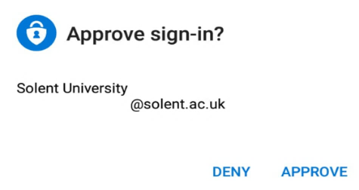
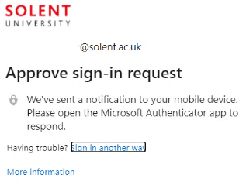
- Just click APPROVE
If you are using the Use verification code configuration, when prompted to Please enter the verification code from your mobile app, enter the 6-digit code from the Authenticator app on your mobile device.
Important - If you receive any sign-in approval request on your mobile device without seeing the first Approve sign-in request prompt on your computer, you should select DENY.
Update your MFA options
You can add multiple ways to MFA by installing the Microsoft Authentication app on multiple phones/devices or by setting up more authentication options.
You can also update your options, to use the recommended app rather than receiving a phone call.
Please note: If you are getting a new phone, set up MFA on your new phone before you get rid of your old phone number or device.
Changing your MFA options
Log in to https://aka.ms/mysecurityinfo with your university credentials on a computer or tablet.
If you are unable to authenticate at all, please contact us for assistance
- For students, please email: LTU@solent.ac.uk and supply your:
  - Username
  - Student ID
  - Date of Birth
  - Course name
  - Screenshot of the error
- For staff, please log a ticket with UNITY
To add a new mobile phone, or additional devices to use the Microsoft Authenticator app.
Watch this video on how to add a new phone (please note: we do not have text method verification).

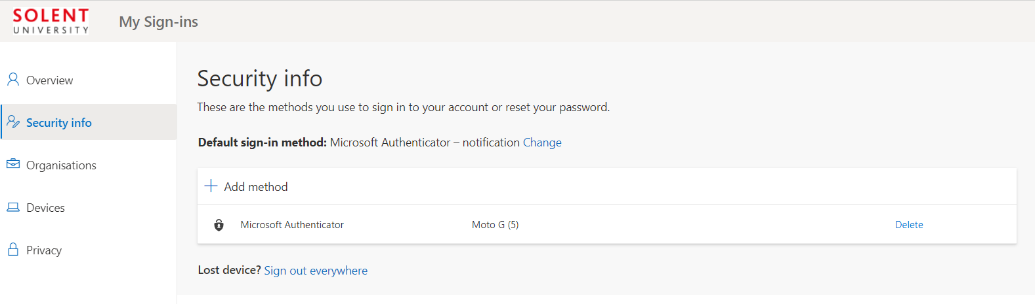
- Click + Add method.
- Select Authenticator app
- Complete steps 3-14 in the MFA Microsoft Authenticator app set up above
To add an additional phone call option
- Click + Add method.
- Select Phone or Alternative phone and enter your telephone details
Following steps 16-20 in the MFA Microsoft Authenticator app set up above
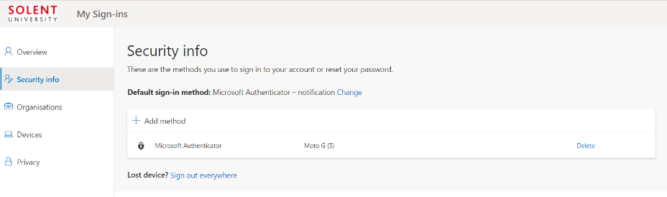
To change the Default sign-in method
- By Default sign-in method: Click Change
- Set to Microsoft Authenticator – notification
- Click Confirm
Remember to click Delete alongside your existing old telephone numbers, or authentication apps.
If you are on a shared computer, remember to sign out (click on your email address at the top right and click Sign out) before leaving.

Having trouble signing in?
If you try to log in but and you don’t have your preferred device available, or you don’t have signal or internet connection, depending on your MFA preferences, you can select Sign in another way.
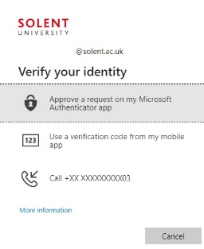
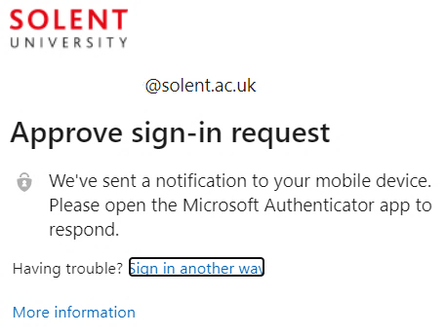
Then choose another method to authenticate depending on what you have set up.
No signal or internet connection?
If your phone lacks a signal, internet connection or you are abroad, and you have the app installed select Use a verification code from my mobile app.
- Open the Microsoft Authenticator app on your phone select the account you are trying to access
- Make a note of the One-time password code
Please note: the authenticator app generates a new code every 30 seconds.
- Enter this into your computer when prompted to sign in.
If you are unable to authenticate at all, please contact us for assistance:
- For students, please email: LTU@solent.ac.uk and supply your:
  - Username
  - Student ID
  - Date of Birth
  - Course name
  - Screenshot of the error
- For staff, please log a ticket with UNITY

