THE BUSINESS PITCH CHECK LIST

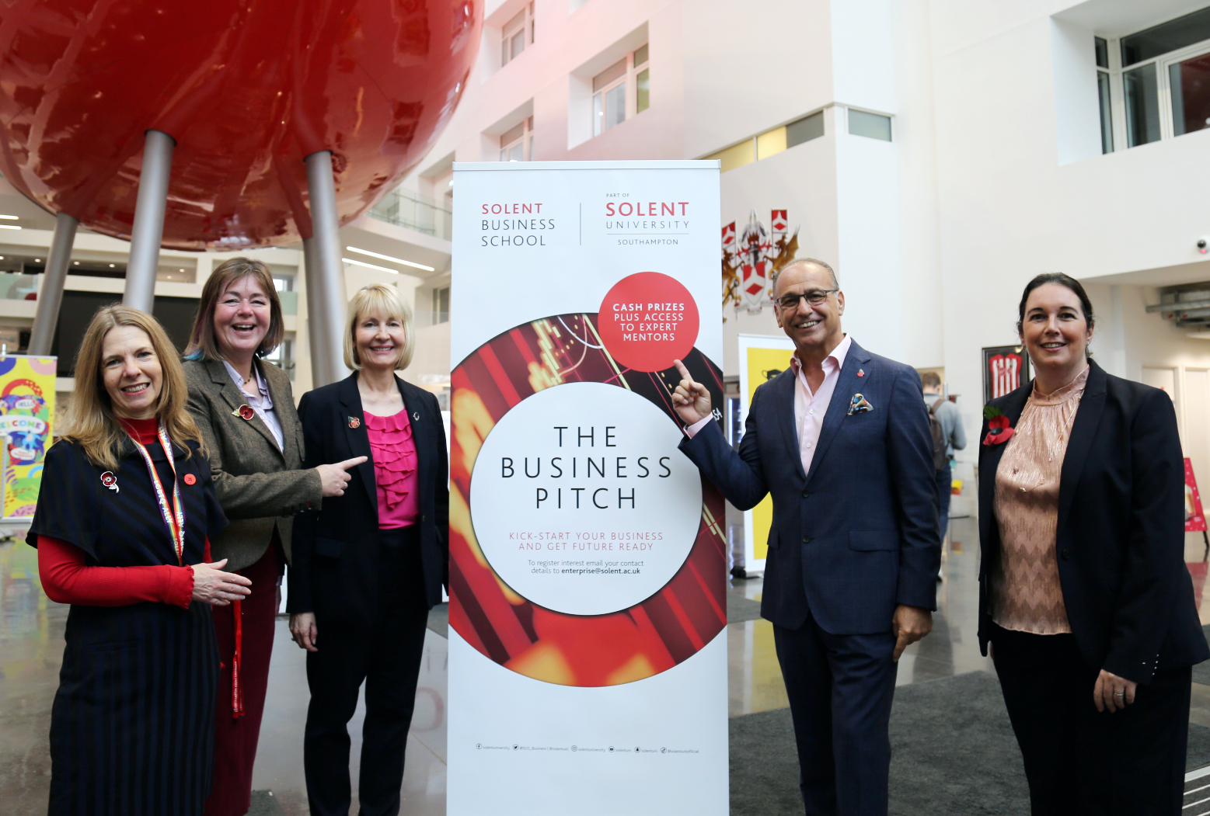

If you are pitching for £10,000 of funding to launch a new business idea or seeking the next level of business growth, then here is a quick checklist to help keep you on track before submitting your proposal. Your submission needs to be uploaded by midnight on Tuesday 3 May 2022.

 | QUICK CHECKLIST | ACTIONED
1 | IT’S GOOD TO TALK  - No business is the same so make an appointment to chat through your ideas and gain lots of support with your pitch and financial projections.  - Email: enterprise@solent.ac.uk to book an appointment with our Business Adviser, Nicky Curtis.
2 | BEFORE YOU START  - Check the criteria - will your business model support the pitching requirements? Is it:  - Innovative and scalable?  - Relevant to Southampton City and the wider community?  - Is your idea sustainable (both financially and environmental)?
3 | PREPARING YOUR PITCH  Financial Projections  You will need to complete your financial projections for 2 years.  You are not being asked for accurate figures of your turnover or expenses, but you do need to begin with the end in mind.  - Have you thought about where you want your business to be in 2 years’ time and provided a clear financial projection?  - Need some extra support? Book an appointment by e-mailing enterprise@solent.ac.uk. If you are only looking for funding for research at this stage, then that’s fine too, we can talk this through.  Preparing your PowerPoint presentation with audio (no more than 10 slides please)  Content  Have you included the following?  - Intro slide – personal details/contact, your degree, graduation year etc.  - About you – what personal attributes/experience do you have that will help you achieve your business idea?  - Your business idea – why is it innovative and scalable?  - How might it support Southampton City and the wider community?  - Your 2 Year Plan – how do you see your business developing. What is plan B if A does not work?  - Financial Information – key highlights from your spreadsheet Turnover, Costs, Net Profit.  - Target Market -who are your potential customers?  - Market Strategy – how do you intend to reach your customers?  - Market Research – who are your competitors?  - Intellectual Property – do you need to protect your idea?  Recording your presentation (10 minutes)  You will need to record yourself with audio and video delivering your presentation.  Top Tips  - Is your background clear and professional?  - Are you presenting clearly at a good pace and with enthusiasm?
5 | SUBMITTING YOUR ENTRY  - Upload the following documents to enterprise@solent.ac.uk  - Your 10-minute video recording of your pitch presentation.  - An extra copy of your PowerPoint slides  - Your financial projections for 2 years  If you have any problems uploading your documents, just get in touch via the e-mail above and we can help.
6 | WHAT HAPPENS NEXT?  A panel will review your application and if you are successful, you will be offered the opportunity to do a stand-up pitch to our Chancellor Theo Paphitis on Wednesday 29 June.  Further support will be available to help you prepare your pitch.  Best of luck and we can’t wait to see your entry!

